Robotics
facultY OF ENgineering
Science
Master of Artificial Intelligence

Homework A
21/04/2026

Enmin Lin
Academic year 2025-2026

Q1
As Fig. 1 shows, one 3-DOF positioning arm can exhibit one, two, or infinitely many inverse position solutions, depending on the target point.
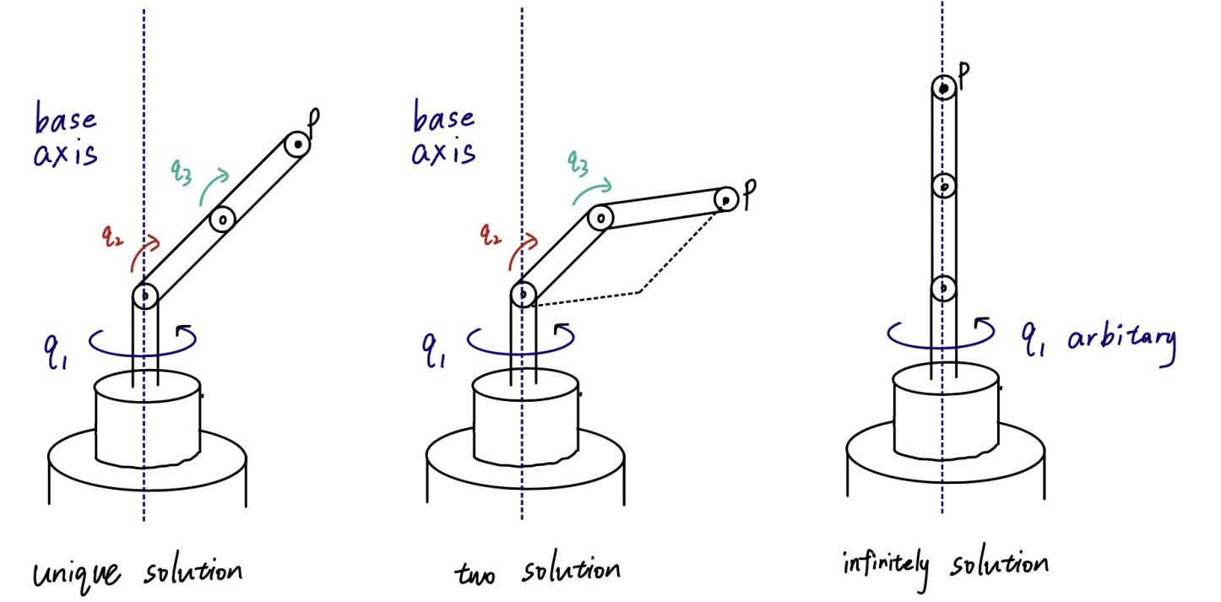
Fig. 1. Three inverse position kinematics cases for a 3-DOF positioning arm with base yaw $q_{1}$, shoulder pitch $q_{2}$, and elbow pitch $q_{3}$.
In the left panel, the target lies on the workspace boundary. The arm is fully stretched, so the elbow-up and elbow-down branches merge into one singular configuration. This gives one inverse position solution.
In the middle panel, the target lies at a generic reachable point. The base yaw stays unique, and the planar two-link geometry gives the standard elbow-up and elbow-down configurations. This gives exactly two inverse position solutions.
In the right panel, the target lies on the base rotation axis. The base yaw does not change the end-effector position in that case. The variable $q_{1}$ is free, so infinitely many inverse position solutions exist.

Q2
I define the configuration of the rolling coin as
$$q=(x,y,ϕ,θ)∈ℝ^{2}×T^{2}.$$
Here $(x,y)$ is the position of the contact point, $ϕ$ is the heading, and $θ$ is the rolling angle. The lecture models this system with two non-holonomic Pfaffian constraints. These constraints do not reduce the dimension of the configuration space. They only reduce the dimension of the feasible instantaneous velocity set.
I use a constructive three-step algorithm.
First, I move the coin to the target position. I turn in place until the heading points to the goal. Then I roll straight until the coin reaches $(x_{g},y_{g})$.
Second, I set the desired heading. I turn in place until the heading becomes $ϕ_{g}$.
Third, I correct the rolling angle without changing the position or the heading. I execute the closed loop
- roll forward by $L$,
- turn in place by $π$,
- roll forward again by $L$,
- turn in place again by $π$.
This loop returns the coin to the same position and the same heading. It still changes the rolling angle by the total rolled distance $2L$. I choose $L$ so that the final value equals $θ_{g}$ modulo $2π$.
This construction reaches any goal configuration $(x_{g},y_{g},ϕ_{g},θ_{g})$ from any initial configuration. The system is instantaneously constrained, but it is globally maneuverable.

Q3
The given rotation matrix is
$$R=\left[\begin{matrix}0 & 0 & −1 \\ −1 & 0 & 0 \\ 0 & 1 & 0\end{matrix}\right].$$
I use
$$tr(R)=1+2cosθ.$$
Since $tr(R)=0$, I obtain
$$cosθ=−\frac{1}{2}, θ=\frac{2π}{3}.$$
Next, I compute
$$[\hat{ω}]=\frac{1}{2sinθ}(R−R^{T}).$$
Because $sin(2π/3)=\sqrt{3}/2$, this gives
$$[\hat{ω}]=\frac{1}{\sqrt{3}}\left[\begin{matrix}0 & 1 & −1 \\ −1 & 0 & −1 \\ 1 & 1 & 0\end{matrix}\right].$$
Matching this skew-symmetric matrix with the standard form yields
$$ω=\left[\begin{matrix}\frac{1}{\sqrt{3}} \\ −\frac{1}{\sqrt{3}} \\ −\frac{1}{\sqrt{3}}\end{matrix}\right].$$
Therefore, one valid set of exponential coordinates is
$$ωθ=\left[\begin{matrix}\frac{2π}{3\sqrt{3}} \\ −\frac{2π}{3\sqrt{3}} \\ −\frac{2π}{3\sqrt{3}}\end{matrix}\right].$$
The pair $(−ω,−θ)$ represents the same rotation, so equivalent answers also exist.

Q4
I use the complete planner suggested by the lecture: a visibility graph in $C_{free}$, followed by A* search on that graph.
As Fig. 2 shows, the point robot moves from the start to the goal through the visible obstacle vertices. For polygonal obstacles and a point robot, this construction is complete.
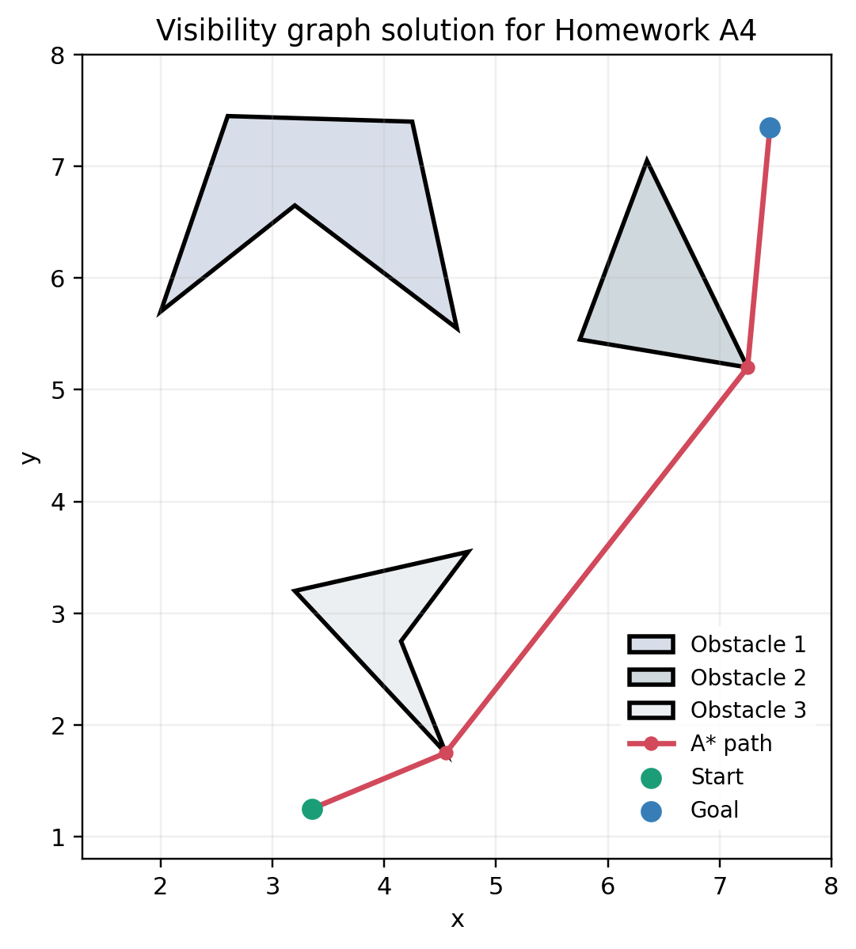
Fig. 2. Visibility-graph path for the point robot in the workspace of Homework A4.
I approximate the obstacle vertices as follows:
Obstacle 1:
[(2.0, 5.7), (2.6, 7.45), (4.25, 7.4), (4.65, 5.55), (3.2, 6.65)]
Obstacle 2:
[(5.75, 5.45), (6.35, 7.05), (7.25, 5.2)]
Obstacle 3:
[(3.2, 3.2), (4.75, 3.55), (4.15, 2.75), (4.55, 1.75)]
I set
start = (3.35, 1.25)
goal = (7.45, 7.35)
The planner returns the path
(3.35, 1.25)
(4.55, 1.75)
(7.25, 5.20)
(7.45, 7.35)
The total path length is 7.840207.

